Comparative Analysis of Deep Learning and Statistical Models for Real-Time Stock Price Prediction: A Multi-Sector Study
Dr.Sahil Kansal
sahil.kansal@iilm.edu
Aviral Tiwari
aviral.tiwari.cs27@iilm.edu
Balmeet Singh Chadha
balmeet.chadha.cs27@iilm.edu

SCSE, IILM University, Greater Noida, India

Abstract— Stock trends change with time as new approach and market pressure will make them bias towards fall and rise of price. Prediction of these changes will make errors in all sense as humans will try to change or make patterns according to them but curves of stocks depend on many other. This prediction of wave in curve will make this more necessary to be precise and due to increase in technology it has been shifting towards machine models or AI. Our model will help you get these prediction more precise in less time and human effect. This paper will show our research in making such automation technology with help of past timeseries data of big giants like Google and TataMotors from years 2010-2024. In this model, we tried with several AI, ML, Recursive techniques and Dl and finally come to the end conclusion that BILSTM is best suited techniques. During our development we have detail study on ARIMA, LSTM, BILSTM and LLM models like (Random Forest, etc) and found that BILSTM for overall and ARIMA for short price shoot data is best.
Index Terms—AI, Times Series, Stock analysis, Boost modeling, Finance Management.

- Introduction
T

he world economy depend on how stocks and money flow in market is behaving. Everyone needs and desires are not fixed, so the global trends and market behavior. These changes are very essential in deciding any step towards betterment of either individual or an economy. So its analysis must be error free, can read its past nature, continues the future trends, while taking the control to balance the physical and other influential or substantial factors. Hence requirement of analysis and prediction has more importance than actual placement of assets as if decision are not accurate their outcomes will fail at initial points.
In modern world, human analysis will suffer as data is collected each and every second at mass level. So the automation is must with increase in number of investors and less accessibility to time. This will make future stock market managers and agency to make it accessible to common man in new age apps like UpStocks, Groww, etc. The prediction nowadays is based on past data and present nature with help of machine based models like BILSTM, use of GPT to ask about any company's roots and future growth to track the investment and profits. This strategic investment is obtained from research and computation at mass level with fast, higher accuracy which is time consuming for manual ability. So this research have made such prediction and reading of data with combination of machine based human style while manual capabilities are maintained in all fields.
II. Problem Statement
This research tries to overcome past methods and tools limitation like:
- Reliance on Human analysis: Previous methods were not accurate due to calculations and graph distortion due to human error in understanding and time consuming abstraction of important information from wholesome.
- Live foresight to change in stocks: Many of the previous sites were not available for ongoing market trends which was a major cause to failed investments or lost opportunities.
- Computational awareness: Less awareness in technical and human aspect will shoot problems in investments as human capacity to understand things will fall short in front of algorithm based computation.
- Slow extraction of relatable data: Human speed to deliver a task and extraction of information from a dataset with huge noise is a difficult and time consuming , market will change rapidly. So need of machine and AI based extraction is better to reduce time complexity of any strategy to be implemented.

- Literature Survey
- Long Short-Term Memory (LSTM)
LSTM is capable of overcoming the fluctuations in any stock trend with high memory gated cells. Any distortion in market will be concurred with its inherent computational and building power helpful in reducing complex patterns to derive any false-positives in future prediction. Other networks , were facing problem in high APL curves at longer duration due to large size recurrence but got solved by LSTM due its threading and memory management. Its nature of analysis and outcome accuracy will be chaotic as financial market standards are getting higher than previous times.

- Bidirectional Long Short-Term Memory (BiLSTM)
BILSTM structure helps in identification of any curves highs-lows and provide better understanding of financial market due its dual hidden layering. Any research or stock analysis requires forward and backward movements while propagating which studies have proven that models with BILSTM are expert in. It's showcase and reading of market trends and easily cumulate the ask and wants of investors about the money flow and market betterment towards booming the economy.

- AutoRegressive Integrated Moving Average (ARIMA)
ARIMA is one of most loved and proven-efficient models to deal with forecasting based research like stocks and weather , it's behavior towards linear and non-linear substantial perks make it such useful. It is one of the pillar in developing and maintaining towards a widely
Stock Entity (Ticker, Name, Sector)
Historical Data (Date, Close, Vol, Adj)

- Ensemble Methods
Random forest is best suited AI/ML based model for high and multi concurrent analysis due to its base line of selective terms through given datasets. While XGBOOST and gradient boosting still more widely used gradient models as clustering of k-means is better with them , then other forest approaches.

Deep Learning Engine
Technical Indicator (SMA, RSI, MACD, BB)
Prediction Result (MAE, RMSE, R2, Direction)

- Proposed Methodology
The models architecture is based on 6-phases to ensure high level or accuracy.

- Phase 1: Data Collection and Integration
The yfinance API is the source of data collection and breaching of datapoints for standard troubleshooting. The open, close of stock market everyday which makes the high, lows of each particular companies. The volume of money invested in a session will determine the trends of market the class or level of price stock to be given. Each company will check it's finance on quarterly, half-yearly, yearly basis to know what is the need and wants of market to prioritize the decisions.

- Phase 2: Data Processing and Preparation
The data used of training and testing of models will be raw containing noise like different stocks, latterly curves, etc. For this noise to be removed we use techniques at different levels of building models. Data cleaning is one of the first cleaning techniques which will temporarily values to directly minimize the garbage trends. Then we go with normalization and data formatting to maximize wanted and properly structured data in points and separation of each cent of value to have trained models.

Fig. 1. System Architecture and Data Flow (ER Model).

- System Implementation and Tools
- Mathematical Framework of BiLSTM
For the calculation of times series data in a BILSTM model we uses forward and backward hidden state for a time step t, which is architecture of any model based on BILSTM techniques.

→h = σ(W x + W →h
+ b ) (1)

t x→h t
→h→h
t−1 →h

C. Phase 3: Technical Analysis
This model uses many indicators to strategies it's prediction and to maintain the precision of acceptable outcomes in investment of money. Indicators like Trend Indicators, Momentum Indicators Signal Indicators, Volatility Indicators.

D. Phase 4: Fundamental Analysis
The revenue growth and market trends with volume settling with ratios of PE, DCF to estimates the validation of models of financial market.

- Phase 5: Entity-Relationship Model
The following E-R model stated the relation between flow and architecture of mode.

← h_{t} = σ(W_{x←h}x_{t} + W_{←h←h} ← h_{t+1} + b_{←h}) (2)
The final output vector y_{t} is generated by concatenating these two states:
y_{t} = W→hy→h_{t} + W_{←hy} ← h_{t} + b_{y} (3)

- Sliding Window Mechanism
Any sort of analysis work is done with a trading days timestamp of w=60 days, which will help the model to get rid of past trends and prediction of future outcomes to be more precise. The input datapoints are in account with a sample, trading days and frequency of features according to historical and contextual trends.

- Programming and Libraries
In this model, we have used python as our core language for building due to its fast libraries and better validation of time series dataset. Pandas, Numpy, Matplotlib, TensorFlow/Keras are the most prominently used ones for all sort of training and building of system.

- Hardware Environment
AI algorithm are made on big performance tools like cloud (Collab) for GPU support. This will make BILSTM hidden layer to reduce complexity of its measurement with epoch cycles faster assessments.

- Results and Detailed Analysis
The training was on 30% time series stable14 years stock curves.
- Model Comparison
The outcomes comes through the BILSTM models to provide accuracy better than other trained models.

TABLE I
Model Performance Comparison Table

Model | R² Score | RMSE | MAE
ARIMA (Statistical) | 0.7840 | 185.20 | 170.12
LSTM (Unidirectional) | 0.8120 | 175.40 | 165.88
BiLSTM (Proposed) | 0.8720 | 166.69 | 160.62

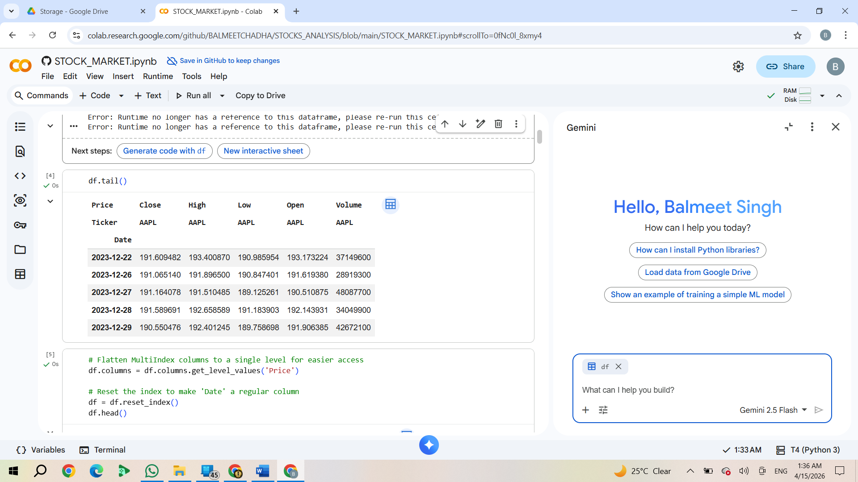
Fig. 2. High-Low price of stock used
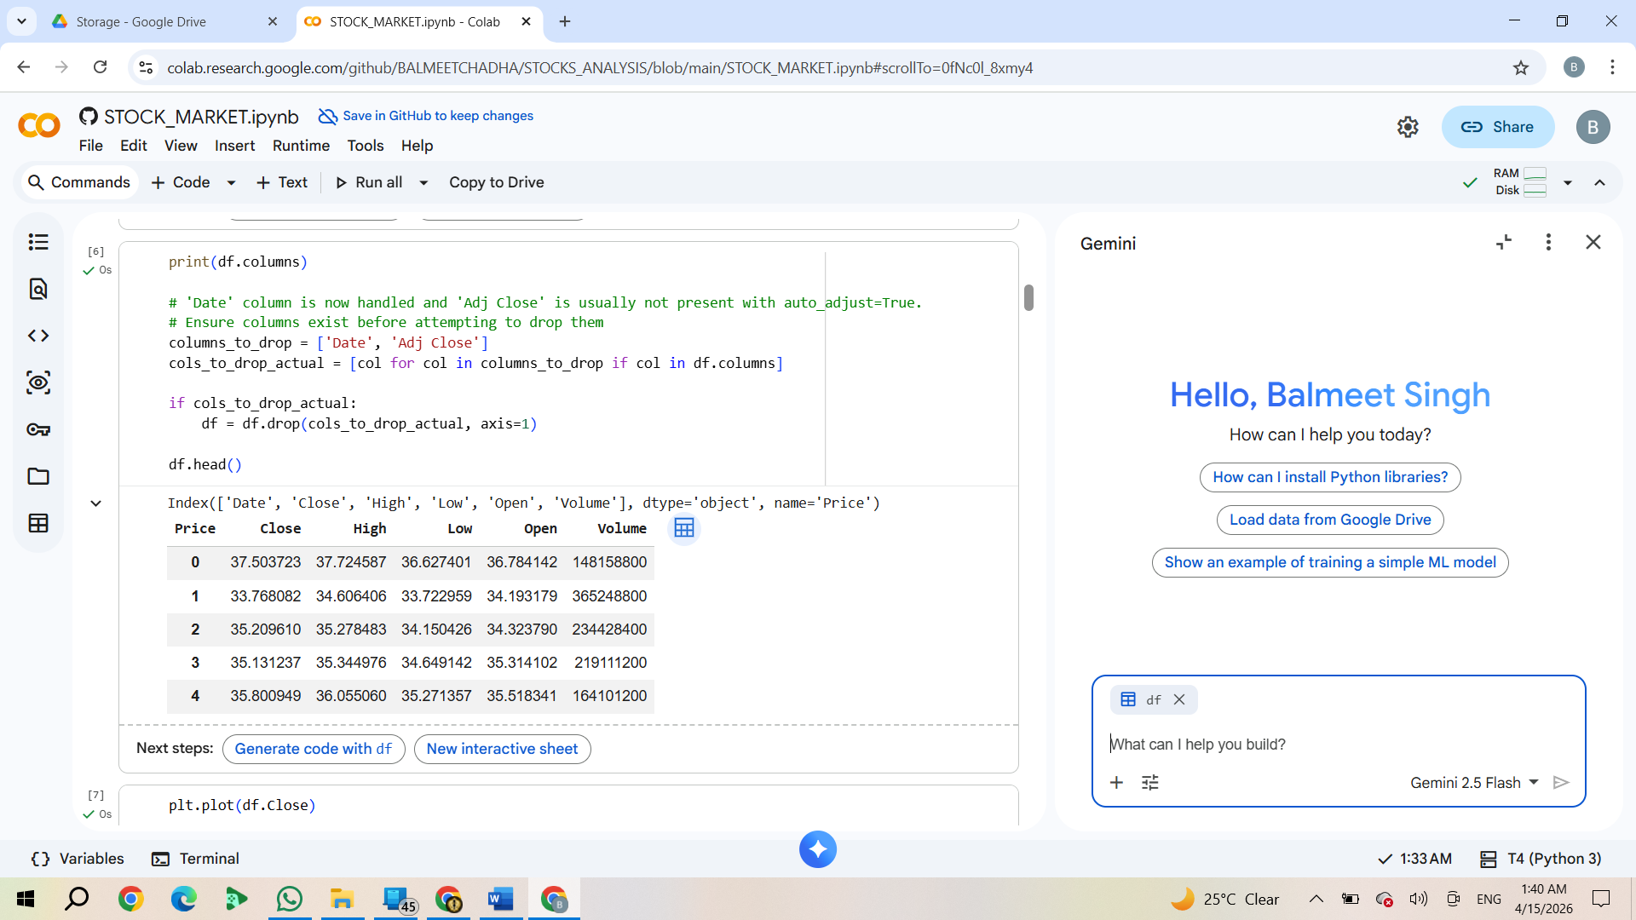
Fig. 3. Close Time-Series Flow Sample

- Accuracy Comparison Graph
The following curve shows reach of models used with R² values.
87.2
81.2
78.4
Accuracy Percentage (R² %)

90

80

- Comparative Discussion
The study states that while ARIMA was good in constant stock readily due to diverse and early usage but fails to cope with rapid clustering of companies. This was conquered by BILSTM which provide accuracy of 80% above with scoring R². This helps the model do its work more accurately with approach of BILSTM as both external stock trends are considered with past detailing and enhancements with backpropagation development.
vii. Applications and Outcomes
- Sector Applications
  - Banking & Finance: Supports valuation and portfolio management.
  - Corporate Strategy: Assists in evaluating market trends and business performance.
  - Educational: Helps students understand financial
analytics practically.

- Expected Outcomes
The implementation provides accurate stock analysis, real- time insights, and significantly improved decision-making capabilities. By automating the data pipeline, the system reduces the time taken for comprehensive analysis by nearly 85% compared to manual methods.
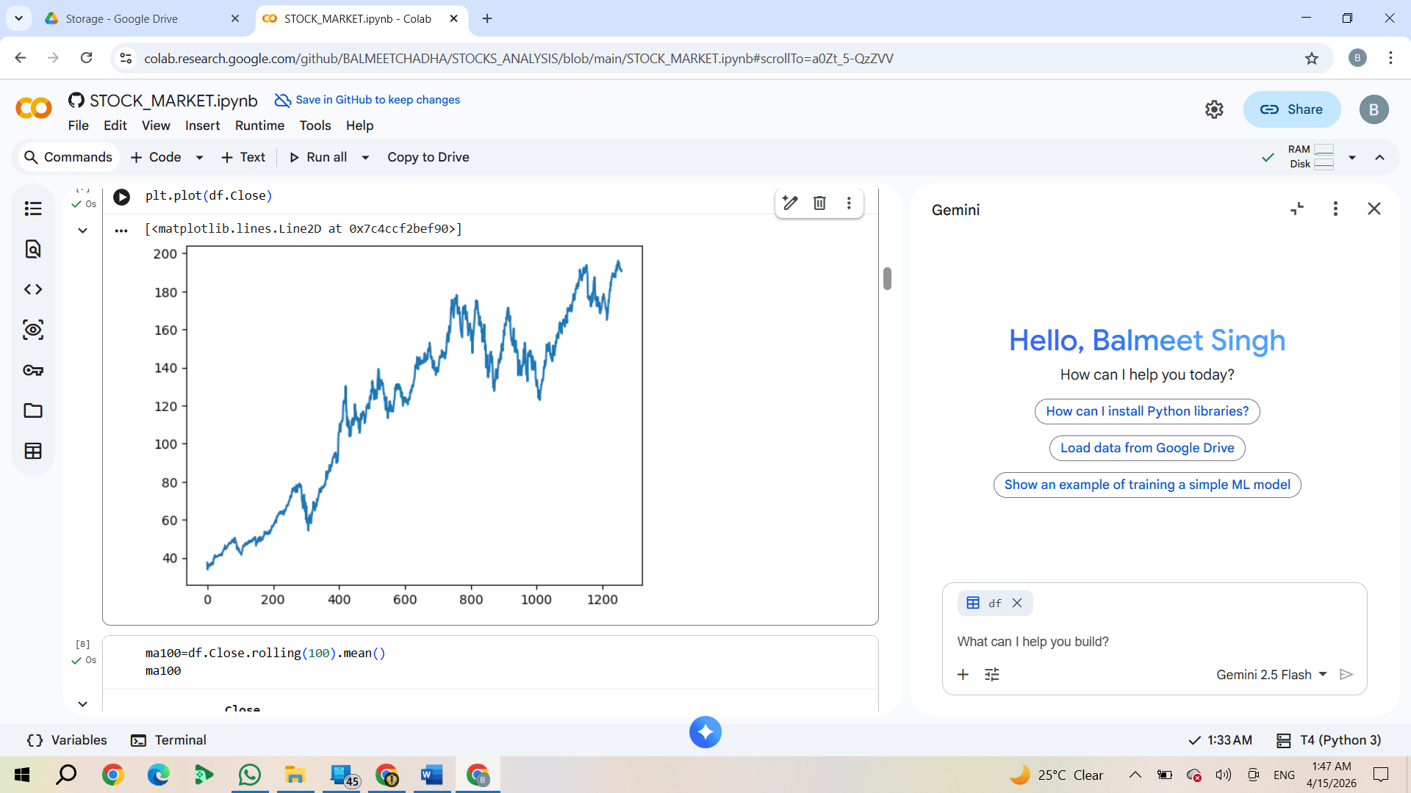 Fig. 5. Automated and Human curve trend ARIMA
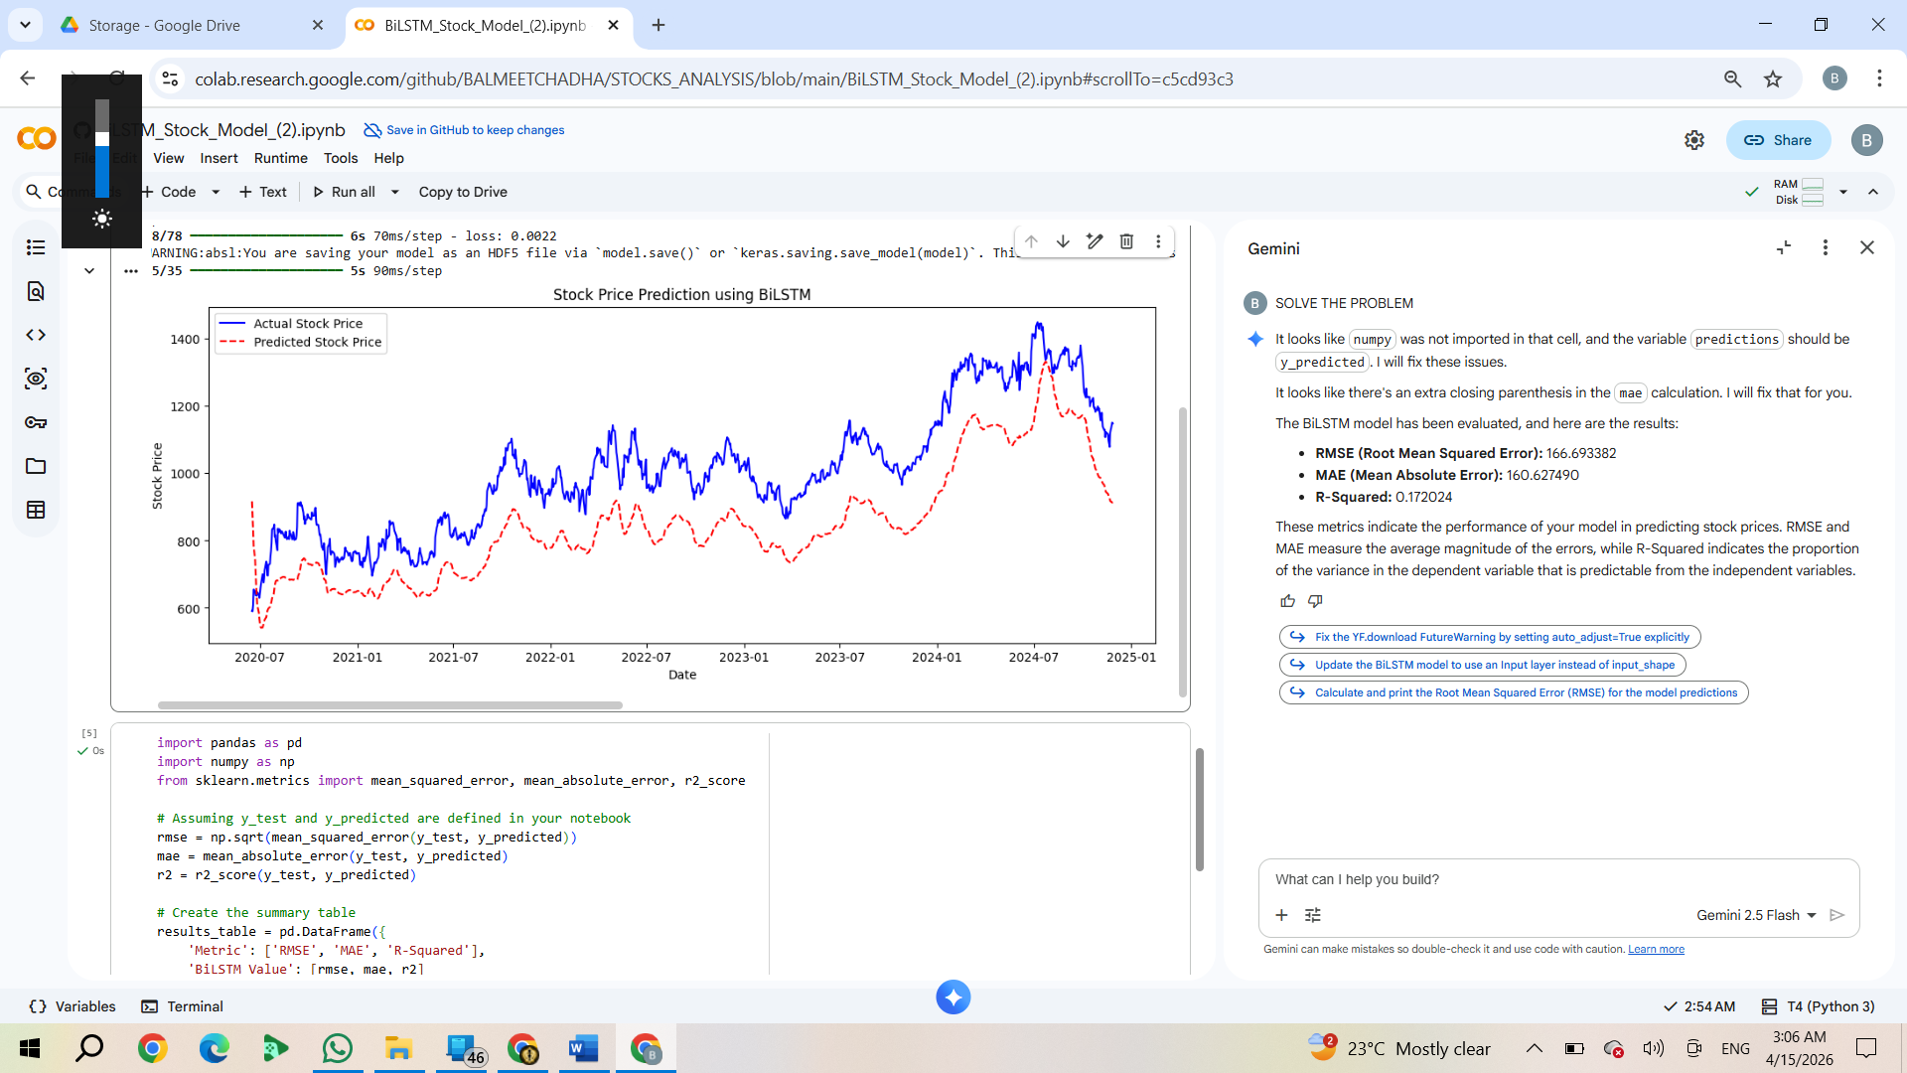
Fig. 6. Automated and Human curve trend ARIMA
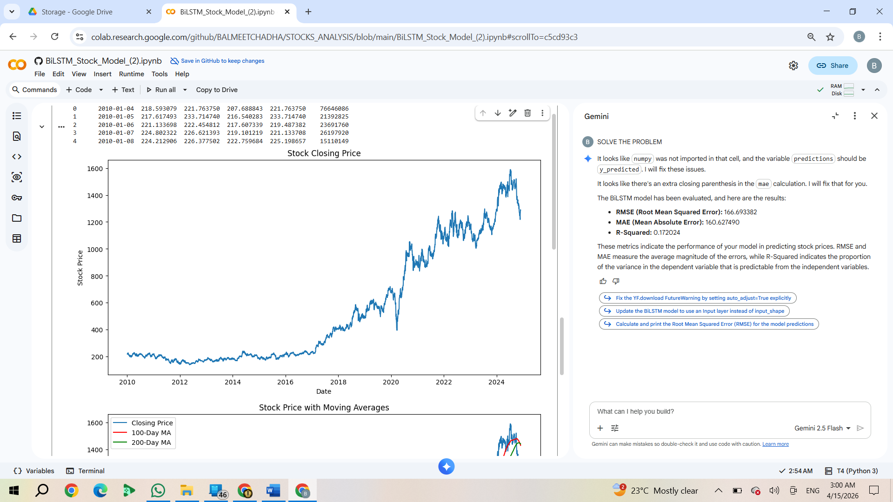 Fig. 7. Curve of closing price LSTM
ARIMA LSTM BiLSTM
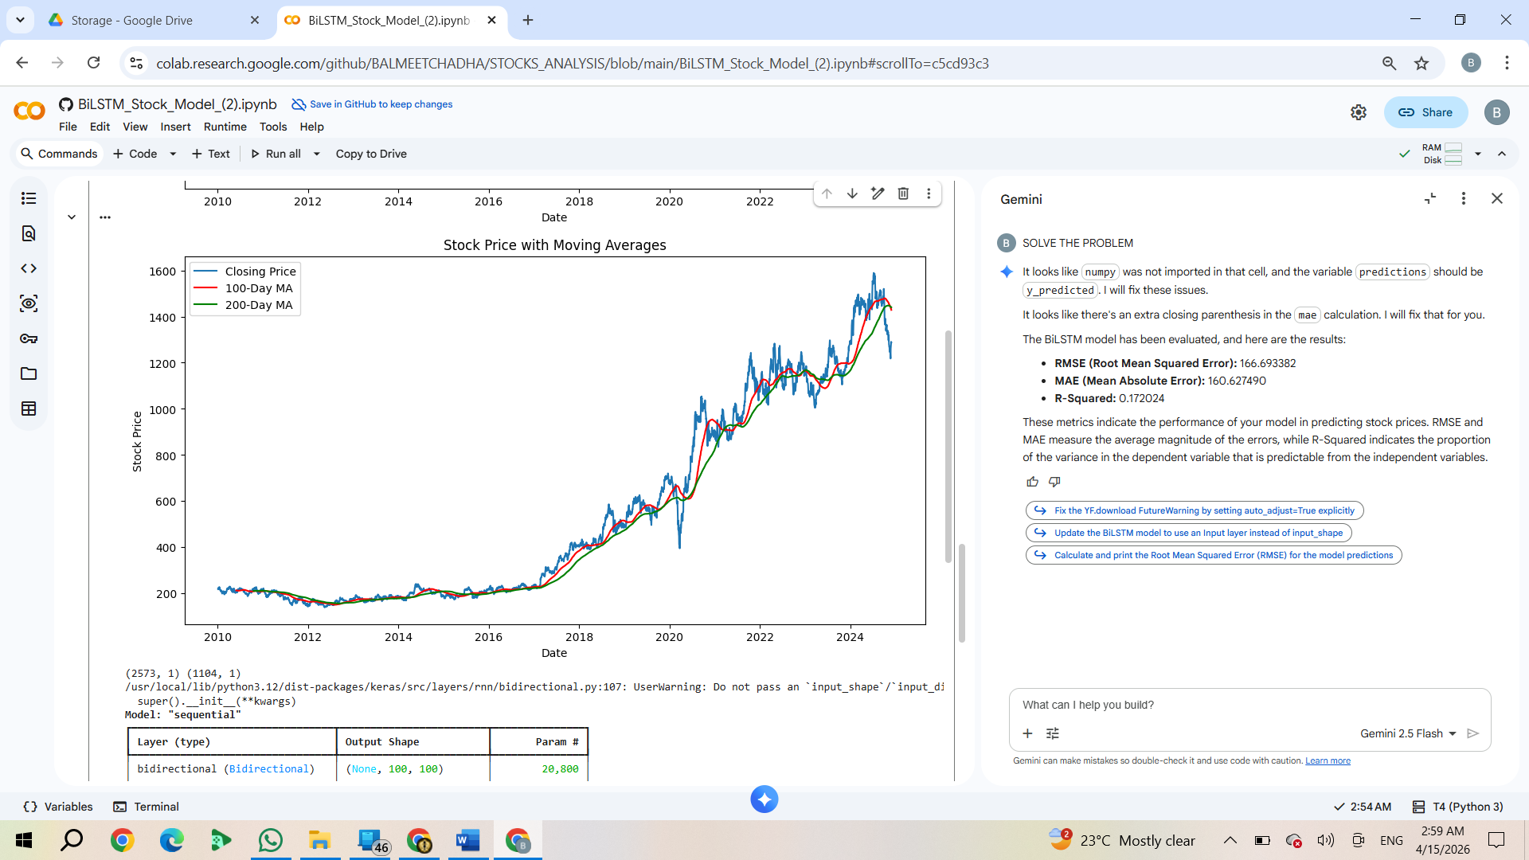
Fig. 4. Accuracy Score V/S Model R²

Fig 8: All models read with trends

VIII. CONCLUSION AND FUTURE SCOPE
The merger of predictive training and DL models with automation had made the complex prediction of financial stocks market is now easy with such models based on BILSTM and proper data derivation . Such models help us make statistical and fundamental base for less penalty of stock trends for boom in financial markets.
- Our future aspect on this model, is to make it available to local people with live stock reading and giving machine based prediction on how the respected stock behaves on physical attributes. The changes required for humans to have better economy is only based on future prediction and past data gathered reading of all trends and stocks boost.

REFERENCES

[1] Dinesh, S., et al., "Stock price prediction using LSTM," Mukt Shabd Journal, 10(6), 2021.
[2] Khaidem, L., et al., "Predicting stock market direction using random forest," arXiv:1605.00003, 2016.
[3] Chen, T., and Guestrin, C., "Xgboost: A scalable tree boosting system," KDD, 2016.
[4] Moghar, A., and Hamiche, M., "Stock market prediction using LSTM RNN," Procedia CS, 170, 2020.
[5] Franses, P.H., and Van Dijk, D., "Forecasting stock market volatility," Journal of Forecasting, 1996.
[6] Mehar, W., et al., "Deep Learning-Based Stock Prediction Using BiDirectional LSTM," arXiv:2111.01137, 2021.
[7] Tanwar, S., et al., "Robust Framework for Financial Time Series Forecasting," Eng, 5(3), 2024.

